Environmental and Social Impact Assessment of the Proposed Development of the ZRENJANIN WASTEWATER TREATMENT PLANT, Serbia

BAckground Information Document

Purpose of this Document
This Background information serves to provide potential stakeholders with information about the Environmental and Social Impact Assessment (ESIA) of the proposed Zrenjanin Wastewater Treatment Plan (WWTP). The disclosure of information forms part of the ESIA “Stakeholder Engagement Process”.

Introduction
The Serbian Ministry of Agriculture, Forestry and Water Management and Metito, a leading provider for water management and alternative energy solutions, have signed an agreement for the development and management of a WWTP. The contract will be implemented as a public-private partnership (PPP). According to the Commission for Public-Private Partnership, the project in Zrenjanin is the first in Serbia in which the PPP model is used in wastewater management. The investment is estimated at EUR 30 million, and the contract was signed for 25 years. The WWTP will be financed, developed and managed by Metito’s Serbia-specific platform company Begej Water d.o.o, and will follow the highest European Union (EU) standards and World Health Organisation (WHO) recommendations, ensuring clean water enters the Aleksandrovacki Canal which joins the Begej River - the centre of the City’s economic, environmental and touristic development.
Metito has commissioned an internal ESIA of the project in order to inform its investment decision. The purpose of the ESIA is to identify and assess the potential social, biological, and physical impacts of the project and determine the required environmental and social mitigation measures. In addition, Metito is committed to complying with the Serbia Law on Environmental Protection (“Official Gazette of RS”, no. 135/2004, 36/2009, 43/2011, 14/2016, 76/2018, and 95/2018) and related EIA requirements.

what is wastewater treatment?
The lack of access to clean water and sanitation services potentially leads to adverse health effects through water-related diseases and deteriorating environmental conditions. Wastewater treatment aims:
- To protect public health
- To preserve the environment
- To provide efficient reuse of treated wastewater

Overview of the Project
Project Location
Zrenjanin City is a city and the administrative center of the Central Banat District in the autonomous province of Vojvodina, Serbia. The WWTP is located in the Zrenjanin Southeast Industrial Zone, east of the Begej River between Zrenjanin City (~3km North West) and Ecka (~2.5km South East).
Construction
The construction of the WWTP is planned to commence in November 2021 and has an 18-month construction timeline. Site Preparation will entail land clearance of vacant state owned land, levelling, delivery of materials and equipment for construction of plant components.
WWTP Design
Primary Treatment
This is the first step in the treatment process and is intended to separate the suspended solids and grit from the wastewater. In the proposed WWTP, wastewater will be initially passed through an Inlet Works Unit consisting of screens the removal of suspended and floating solids, and a grit removal unit which perform the screening and grit and grease removal operations.
Biological Treatment
Primary treatment is intended to remove dissolved organic matter from wastewater. In the proposed WWTP the biological treatment is achieved in three zones: anaerobic, anoxic, and aeration. The treatment processes which take place in each zone is summarised below:
- The anaerobic treatment process removes of bio-phosphorous from the wastewater. This is achieved through a biological process where biological organisms consume the phosphorous which is metabolised for energy and growth.
- The anoxic treatment process is a biological process where in the absence of oxygen, biological organisms convert nitrates contained in the wastewater to nitrogen.
- The aeration process is a biological process where in an oxygen-rich environment microorganisms are used to remove the remaining dissolved organic matter contained in the wastewater. Planned technology at this WWTP is a state of the art Integrated Fixed Activated Sludge (IFAS) process. This is a combination of an Activated sludge process where the microbial growth is suspended in an aerated water mixture, and a Moving Bed Biofilm Reactor (MBBR) where the microbial growth occurs on fixed films.
Secondary Treatment and Disinfection
Biological treatment is followed by settling where big particles or flocs will settle at the bottom of clarifier tanks. The remaining clear water overflows from the top of the tanks into the disinfection stage. In the disinfection stage ultra violet (UV) light is radiated through the treated effluent which inactivates microscopic organisms such as bacteria, viruses, protozoa and other pathogens. Following UV treatment the water will discharged to the Aleksandrovacki Canal in accordance with environmental discharge standards.
Sludge Management
Settled organic matter generated in the WWTP is partially recirculated in order to maintain the biological mass in the process; however the WWTP will generate surplus sludge requiring management. Initially, filter presses will be used to reduce the volume of sludge and increase solids concentration from 1-2% to around 20%. The dewatered sludge will be transported for disposal at the ASA-owned sanitary landfill in the Municipality of Kikinda until alternative waste management options are developed by third parties in the future, which may include composting; co-incineration; and co-incineration in cement production.

Overview of the ESIA Process
The ESIA/EIA includes a stakeholder engagement process. Stakeholders are persons or groups who are directly or indirectly affected by a project, as well as those who may have interests in a project and/or the ability to influence its outcome, either positively or negatively. The stakeholder engagement process allows an opportunity whereby stakeholders can submit their views on the project, which are taken into consideration in the investment decision (by the promoter) and the EIA decision by the Serbian Environmental Authority.
Stakeholder engagement is scheduled to take place between June and August 2021. The stakeholder engagement team will endeavour to engage stakeholders in the following categories:
- Government authorities at the regional and local levels; including city councils
- Local communities within 2km of the proposed WWTP (including those that may encounter negative and positive impacts differently such as elderly, youth, and women)
- Political parties and movements in Zrenjanin
- Civil organizations (non-governmental organizations) and eco activists
- Sport and recreations organisation, users of area, tourism services providers
- Business and business associations

How to Contact Us
Contacts for enquiries related to the ESIA/EIA of the Zrenjanin WWTP Project are below.
Att: Gojkan Stojinović
Position: Local expert
Email: gojkan.stojinovic@gmail.com
Telephone: +381 62 5800 50

Please insert your personal details below:
Name:
Organisation & Designation:

Address:

Tel:
Fax:
E-mail:
I would like to receive my notifications by: (please tick the appropriate box) | Letter (mail)  ☐ | E-mail  ☐ | Fax  ☐ | Telephone  ☐
Please disclose below any direct business, financial, personal or other interest that you may have in the proposed project and associated ESIA:

Please list your project-related comments below:

Please list your project-related concerns / grivenaces below:

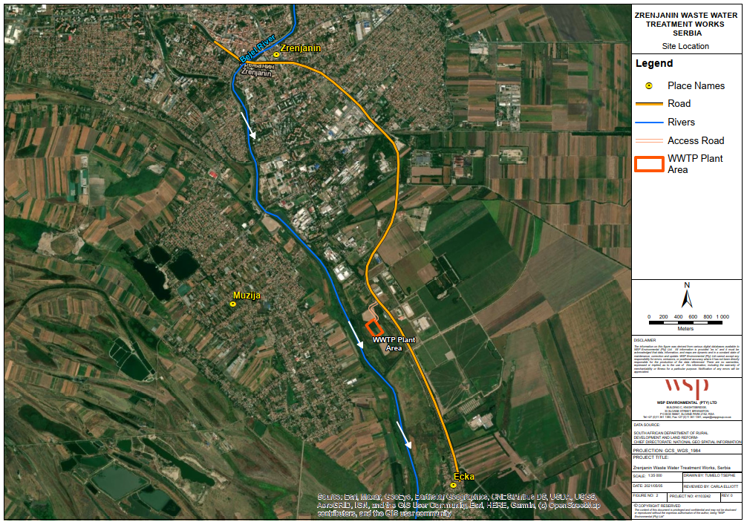

Figure 1 Location of WWTP site (WSP, June 2021)
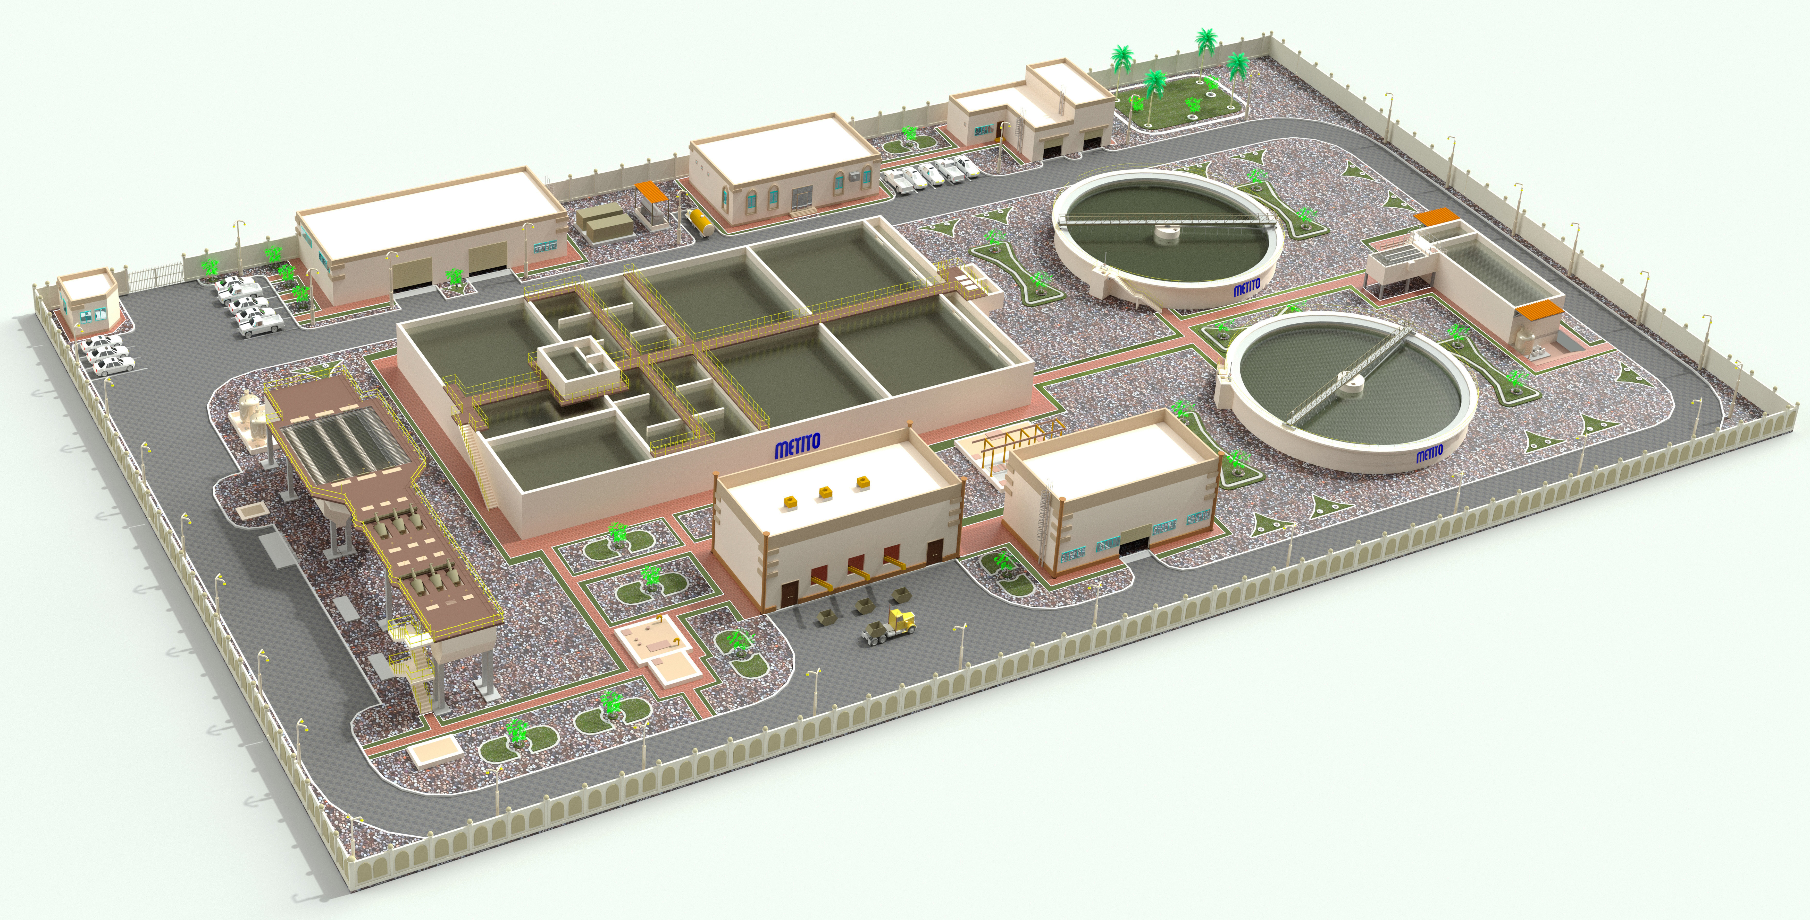

Figure 2 3D Drawing of Proposed WWTP Facility (Metito, June 2021)

